**Assignment 3**

**Health Indicators Across Developed And Developing Countries**

**[2000- 2020]**

**SK JANE ALAM**

**Examination Roll No.: 21227707254**

**Department Roll No.: 328**

**Department of economics**

**Delhi school of economics**

**EC410: Coding Basics with Economic Applications**

**Prof. Devesh Birwal**

**August 1, 2022**

**Source: https://databank.worldbank.org/source/health-nutrition-and-population-statistics#**

**Health Indicators Across Developed And Developing Countries**

For this project, I have imported data from the world bank data website on world development indicators. The imported data are on Mortality rate, infant (per 1,000 live births), Life expectancy at birth, total (years), Capital health expenditure (% of GDP), Domestic general government health expenditure (% of GDP), Birth rate, crude (per 1,000 people), Death rate, crude (per 1,000 people).

Mortality Rates

Infant mortality is the death of young children under the age of 1. It is measured by the infant mortality rate (IMR), which is the probability of deaths of children under one year of age per 1000 live births.

We can see from the graphs below that the graphs are almost the same for developed countries like Australia, France and Japan.

While Mexico’s mortality rate decreases steadily.

Here India and Uganda shows sharp result of decreasing mortality rates.

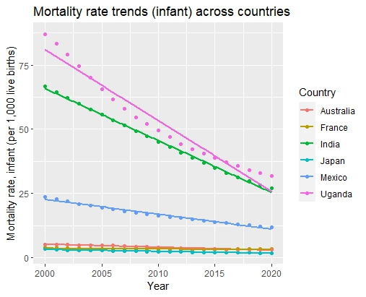

Life expectancy at birth across countries

 The average number of years that a new born could expect to live, if he or she were to pass through life exposed to the sex- and age-specific death rates prevailing at the time of his or her birth, for a specific year, in a given country, territory, or geographic area.

Life expectancy at birth across countries is almost same or stable among France, Japan and Australia, while Mexico is just below these three developed countries.

On the other hand India’s performance is impressive as its health sector improved a lot.

Uganda shows a significant improvement over the years.

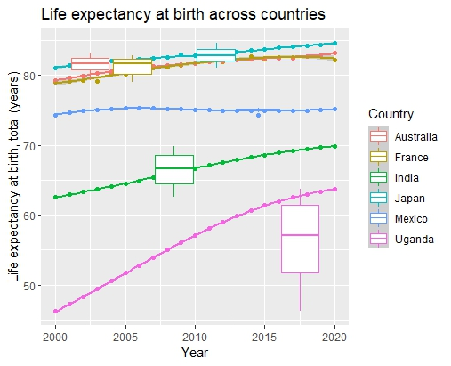

Comparison between India and Japan :

As compare to Japan India shows much improvement over the years .

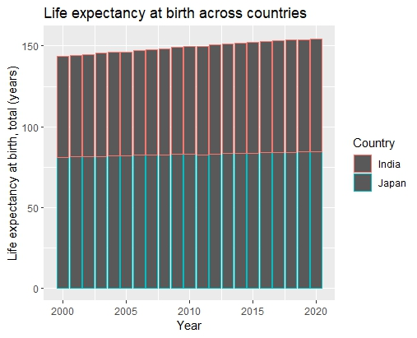

Comparing Capital health expenditure across countries:

India’s capital expenditure has increased over the years while other countries fluctuate according to their economic condition.

Like France has increasing its health expenditure till 2010, after this year it’s been decreasing ever. Similarly Australia showing same trend, while Japan lies below Mexico in its health expenditure.

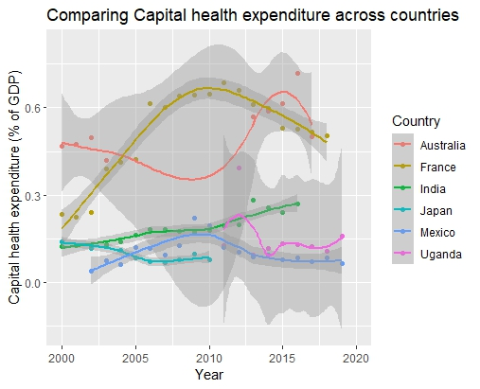

Domestic general government health expenditure :

Government of France and Australia consistently increasing its health expenditure while Japan raises its expenditure sharply by 2010. On the other hand India’s health expenditure remain stagnant throughout the years. And Uganda’s health expenditure decreases over the years.

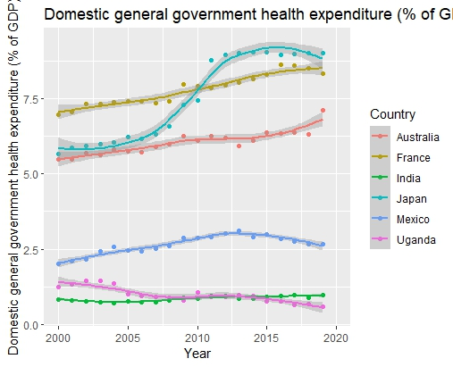

Birth rate trends across countries :

Birth rate is the total number of live births per 1000 of a population per year. With great development and other changes, change in birth rates have also been observed.it is also observed that there are higher birth rates in developing countries as compared to developed ones due to various factors.

Uganda has showed stellar performance over the years on level of world population aspect.

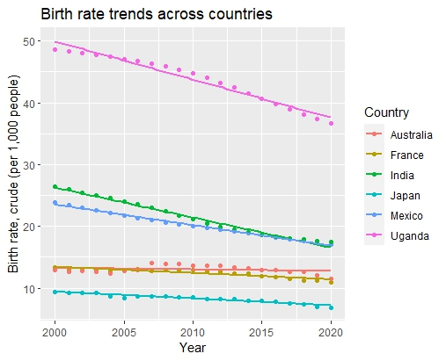

Death rate across countries :

Death rate: This entry gives the average annual number of deaths during a year per 1,000 persons at midyear; also known as crude death rate. The death rate, while only a rough indicator of the mortality situation in a country, accurately indicates the current mortality impact on

population growth. The death rate of Mexico, Japan and France has increases at a decreases rate over the years while in Uganda death rate decreases sharply. India’s performance in health sector improved a lot with stagnant budget.

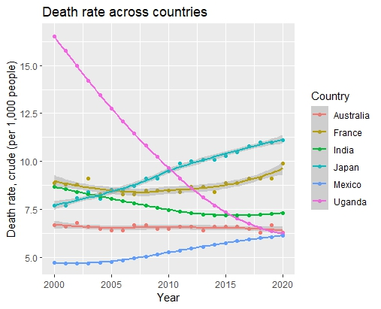

Conclusion

From the above graphs, we can observe that India’s performance in health sector has increase to tackle mortality rate, life expectancy, death rate, birth rate etc. despite its stagnant health budget over the years.